CMIS

USER

MANUAL

### PREPARED FOR

Savannah River National Laboratory

### PREPARED BY

Roy Njeru

Evan Crane

Bilal Sellak

# Logging In

* Logging in involves inputting your username and password provided by an administrator
* To login, proceed to type both your username and password and click the sign in button

# Logging Out

* To logout, click the logout button, available on the upper right corner of any page
* Logging out will return you to the Login page

# Browsing Collections

* Browsing collections is available from the Home page, accessible from the Home button on the top menu bar

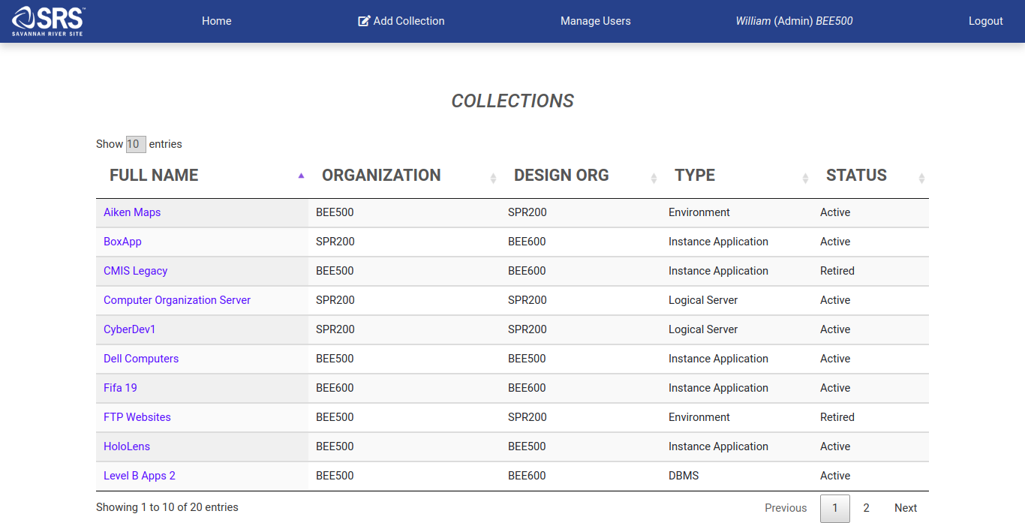

* The browsing table can be sorted by the prefilled attributes:
  + Status
  + Type
  + Name
  + Design Org
  + Organization
* You can select more collections to display by adjusting the Show Entries label at the top left of the table
* To view additional collections, you can select the next button or a page number from the bottom of the table

# Viewing Collections

* To view a collection, click on the collection from the browsing table
* The view will be broken up into sections:
  + **Collections**
    - **Properties Contained:** Full Name, Acronym, Collection Type, Status, Backup Server, Service Type Provided, Organization, Design Agency Organization
  + **General**
    - **Properties Contained:** User Population, Primary Customer, Subcontractor Maintainer, Description
  + **Controls/Impacts**
    - **Properties Contained:** Function class, Data Classification, Mission Essential Rating
  + **Contacts**
    - **Properties Contained:** User Id, Name, Contact Type, Phone Number, Location
  + **Vendor Products**
    - **Properties Contained:** Product Name, Version, Description, Classified Information
  + **Subobjects**
    - **Properties Contained:** Type, Name, Version, Classified Information
  + **Relationships**
    - **Properties Contained:** User Id
  + **Editors**
    - **Properties Contained:** User Id

# Editing Collections

* To edit a collection, proceed to click the edit button at the bottom of a specific Collection’s detail page

# Adding Collections

* To add a collection, click the Add Collections button at the top menu bar
* At the Add Collection page, you have several options to fill in:

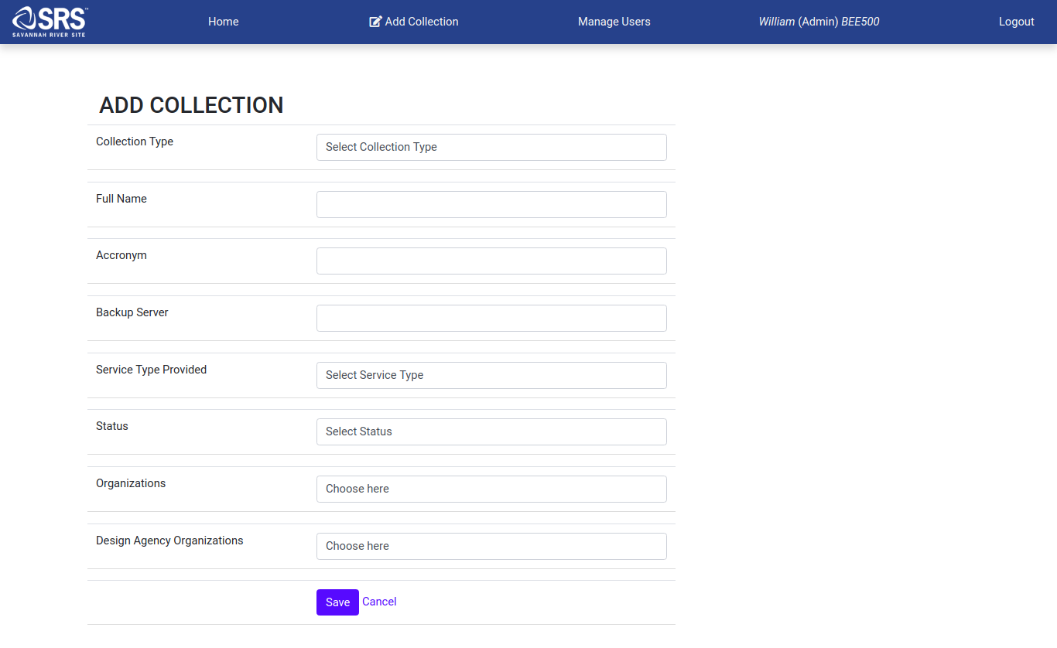

* These consist of several properties:
  + **Collection Type**
    - **Options:** Logical Server, Environment, DBMS, Instance Application
  + **Full Name (Unique)**
  + **Acronym**
  + **Backup Server**
  + **Service Type Provided**
    - **Options:** Sandbox, Development, Production, Acceptance, Disaster Recovery
  + **Status**
    - **Options:** Active, Retired
  + **Organizations**
    - **Options:** Organizations within user’s scope
  + **Design Agency Organizations**
    - **Options:** Design Agency Organizations within user’s scope

# Deleting Collections

* To delete a collection, proceed to click the delete button at the bottom of a specific Collection’s detail page.

# Managing Users ( Admin Rights Required )

* Admins will be able to access the User Management page by a special option available to them on the top menu bar

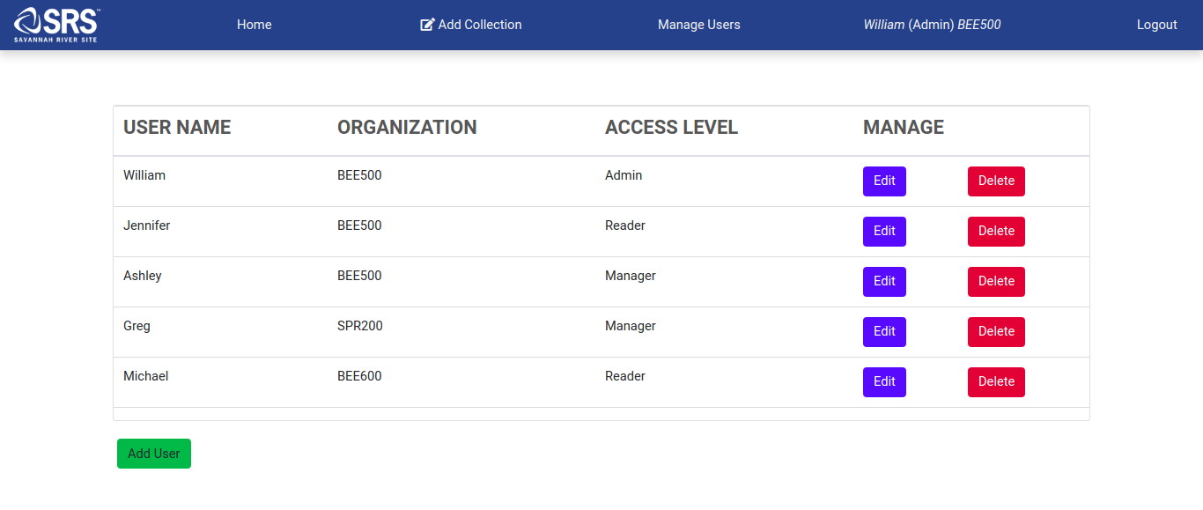

* Deleting users is done by selecting the Delete button in that user’s row
* Editing users and Adding users are both done by selecting their respective buttons and bring up the Add/Edit User popup

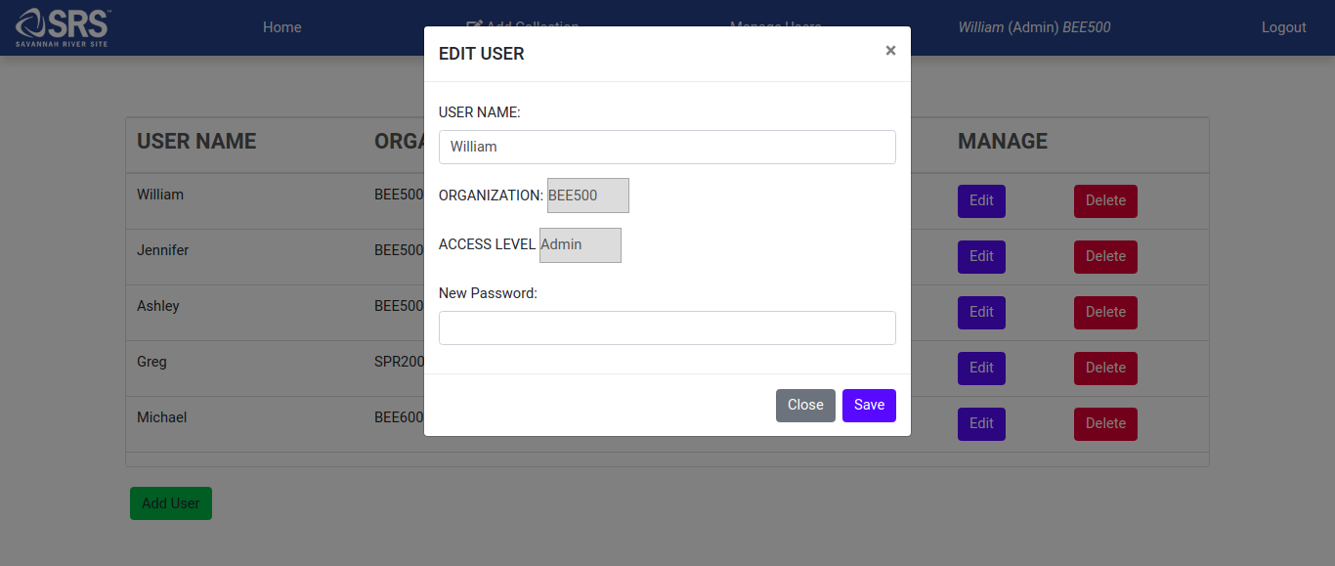

* This allows an admin to select new properties:
  + Access Level, Password, Username, Organization